**Step1: Create the “ICLP-Phase1-prod-intel.zip” file**

* Download the ICLP GVA source code from the FTP site.
* Unzip the zip file into a directory.
* Using Windows Explorer goto “gva\deployScripts\azure” directory
* Right click on the “ICLP-Phase1-prod-intel” directory, and create a zip file with the same name. it is important that the directory structure is retained in the zip file,,

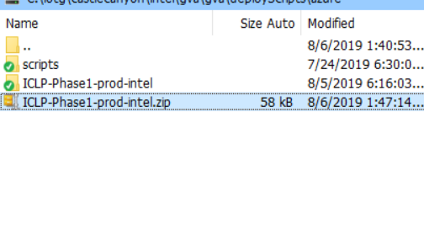

**Step2: Setup the SDS deployment service..**

* Goto <https://sds.azureiotsolutions.com/>
* Click on “Solution Authoring” (top right of page)

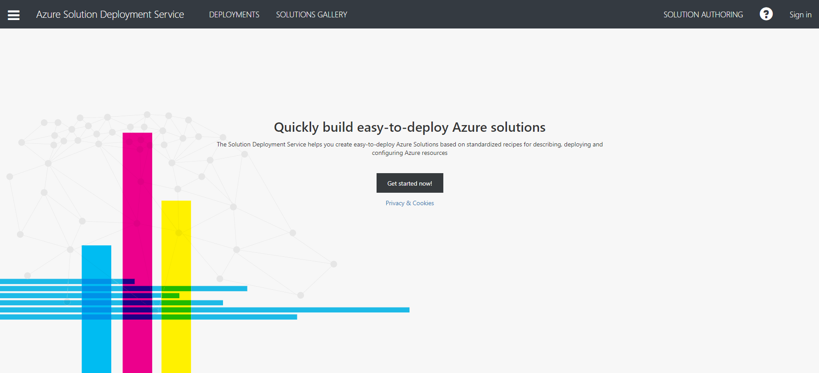

* Provide your Azure login credentials (if required)
* Then select 

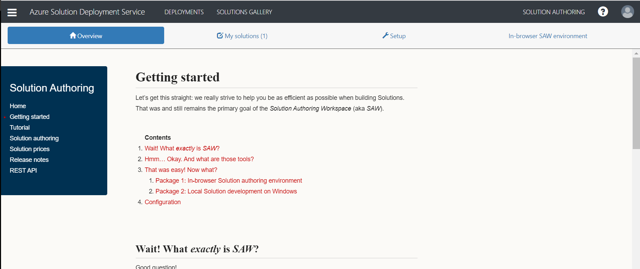

* Turn on the “Authoring Feature”

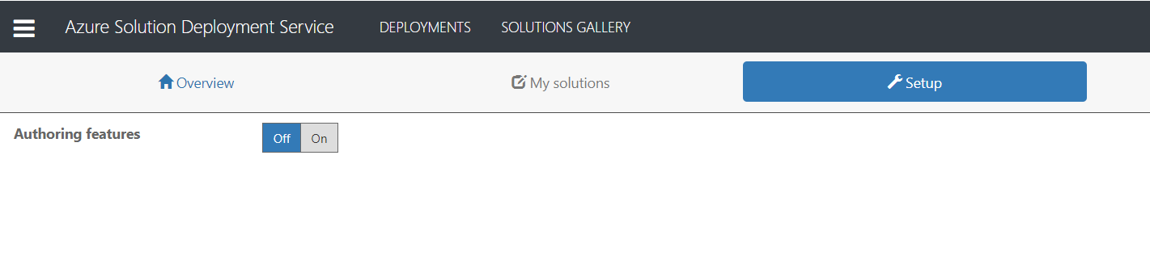

* Choose you Azure Subscription, allow the Azure Location to be default, and App Service Tier and be “free”

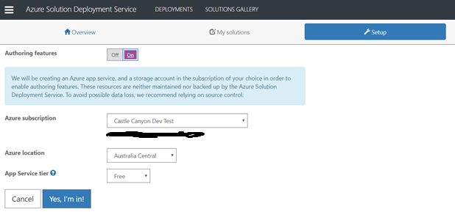

* Click “Yes, Im in!”,, this process will take a few minutes to finish..

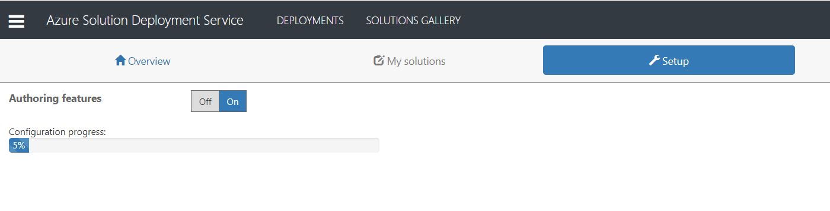

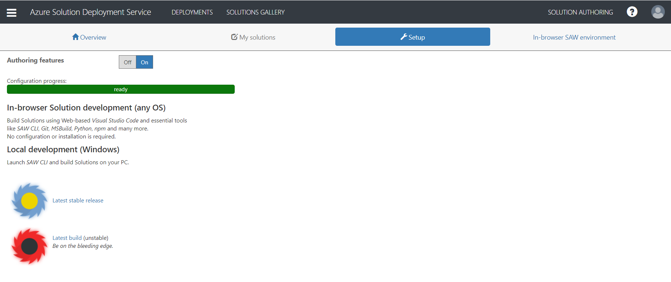

* In case this step fail,, please retry by using a different “location” or “pricing” tier.

**Step3: Setup the ICLP Deployment service.**

* Once the Authoring Feature is “Ready” for use, click on the drop down menu “In-browser SAW environment” and choose “Open in new window”,, (this page seem to have an error, you might have to reload the page to display these menu options),, after you select this option, a new window will open with the App Service Editor..

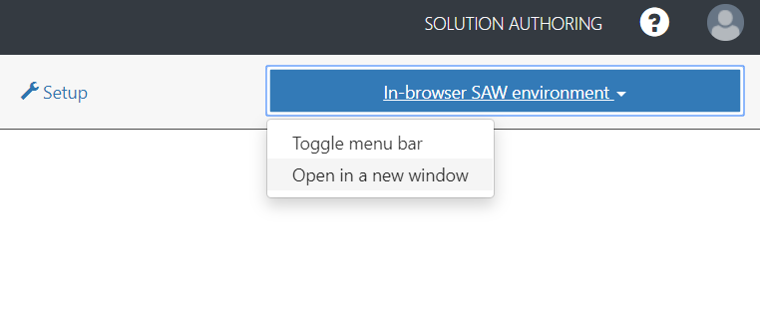

* The new Windows should look like this :

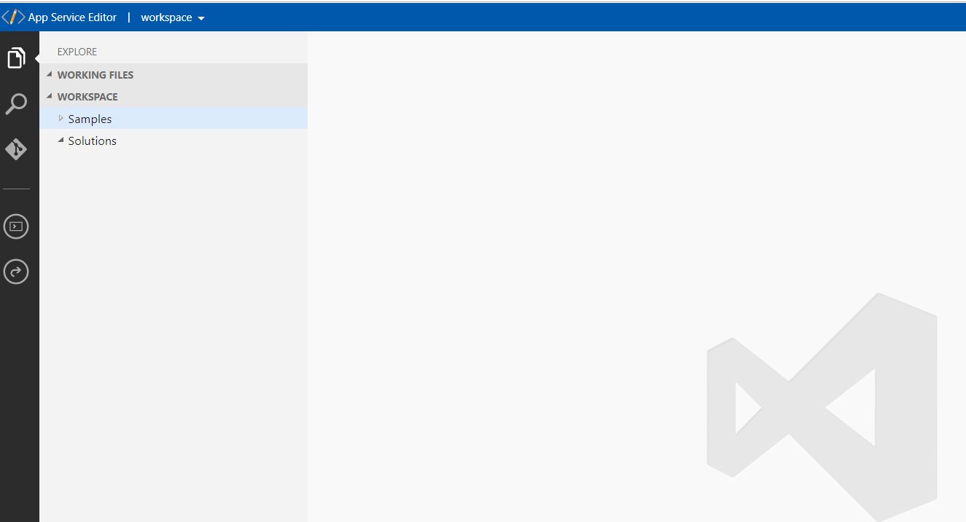

* Drag and drop the “ICLP-Phase1-prod-intel.zip” file you created as part of Step1, under the “Solutions” folder:

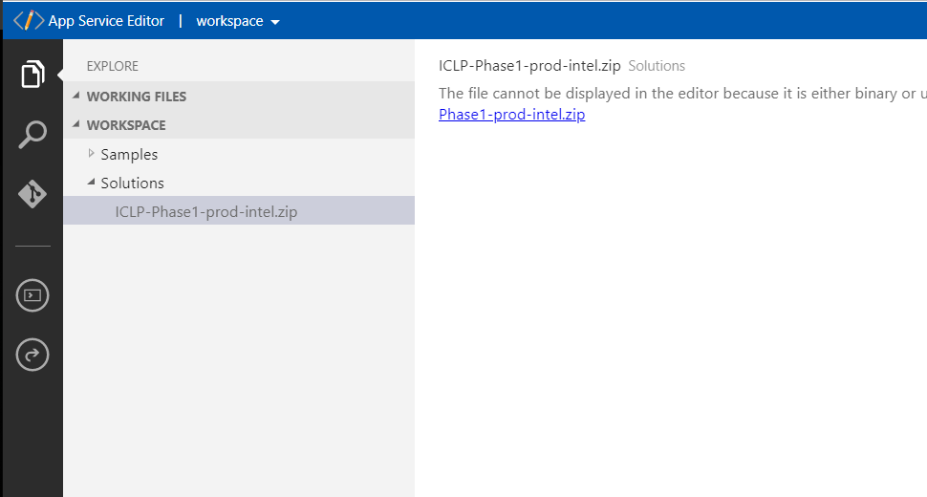

* Right click on the “ICLP-Phase1-prod-intel.zip” file, and choose “Extract All”,, this should create a directory structure as follows, and will also open a console window on the right:

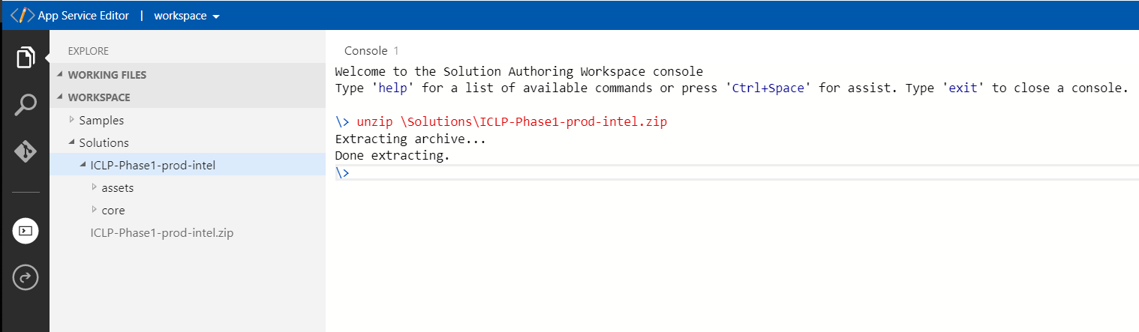

* In the console window type “saw push” to install the solutions, you should get the following success messages:

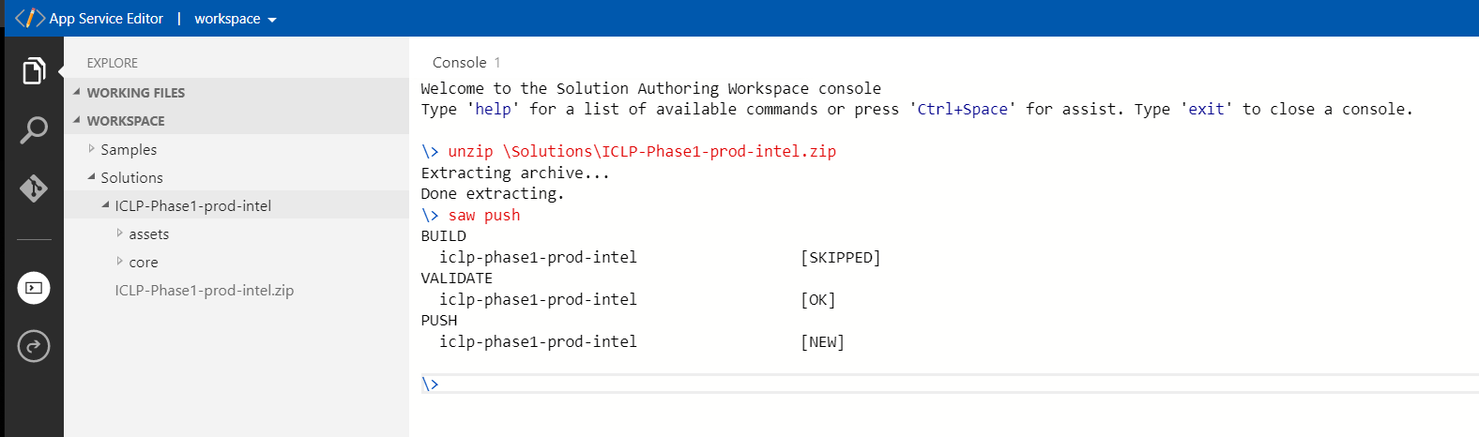

* This complete this step..

**Step4: Deploy ICLP instance.**

* Go back to <https://sds.azureiotsolutions.com/>, you should now see an additional solution available under “My Solutions”, .. go ahead and click on this.,. then you should see the ICLP solution available for deployment..

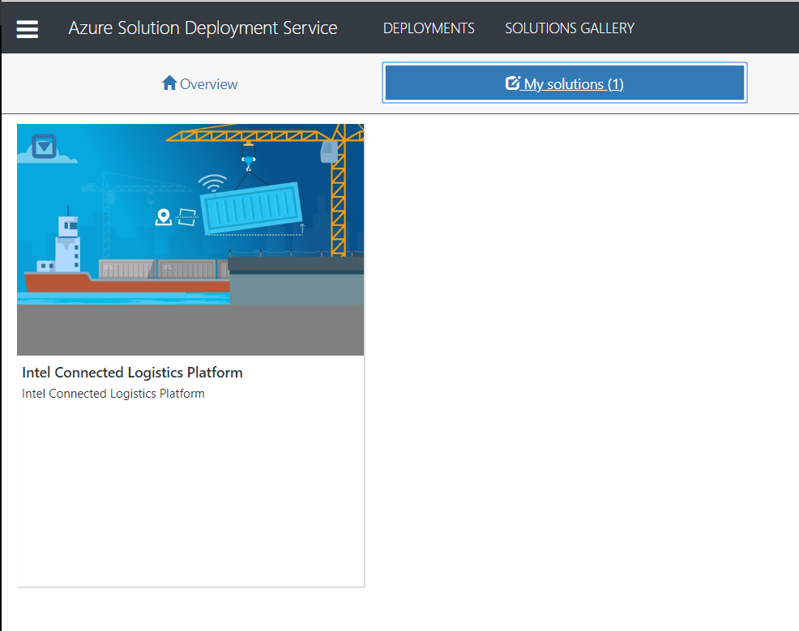

* Click on the arrow on the ICLP icon, this will reveal a menu with deployment options. Choonse “Deploy”

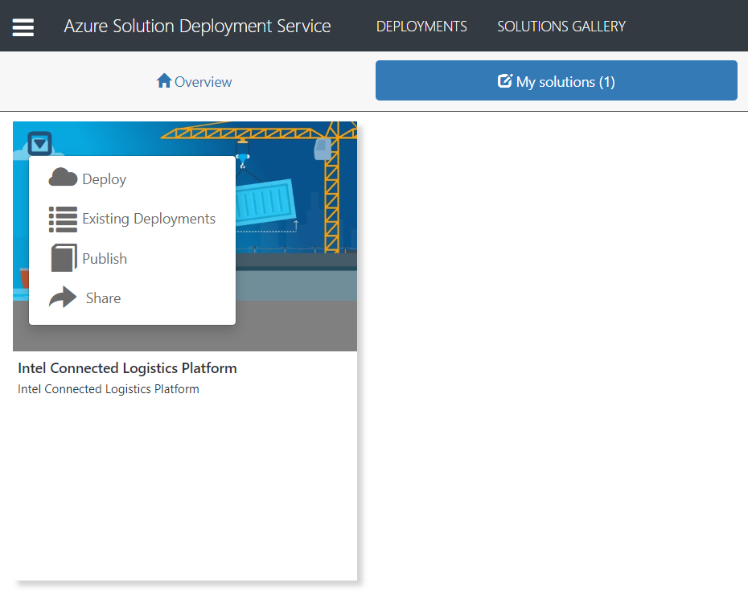

* Provide the necessary details to deploy your solution, and then click “create”

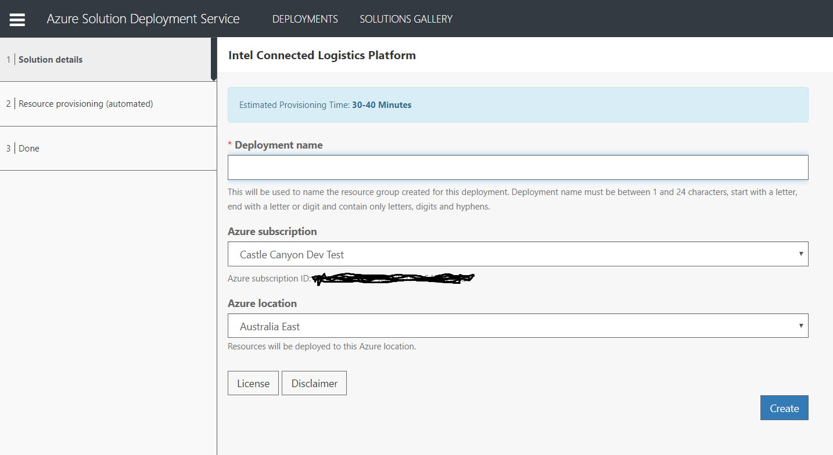

* Automated deployment will start:

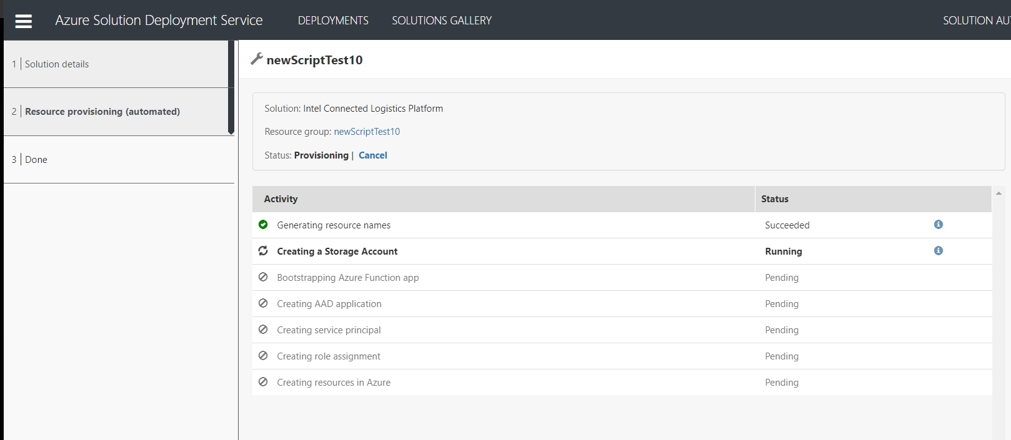

* Once this is completed, you will see the following screen (in case there were no errors),, click on the link to log into your VP..

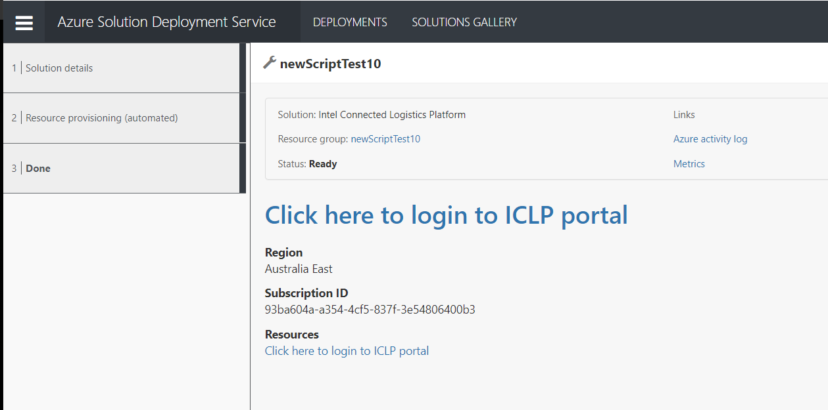

* For VP, default username: deskagent@localhost, password: deskagent



